Final Project Report

Shapes Classification using SVM



Project Supervisor
Noor Rahman Mahsud

Submitted By

Ayesha Saleem Mc190405852

Software Projects & Research Section,
Department of Computer Sciences,
Virtual University of Pakistan


CERTIFICATE

This is to certify that Ayesha Saleem (Mc190405852) have worked on and completed their Software Project at Software & Research Projects Section, Department of Computer Sciences, Virtual University of Pakistan in partial fulfillment of the requirement for the degree of BS in Computer Sciences under my guidance and supervision.
In our opinion, it is satisfactory and up to the mark and therefore fulfills the requirements of BS in Computer Sciences.

Supervisor / Internal Examiner

Noor Rahman Mahsud
Supervisor,
Software Projects & Research Section,
Department of Computer Sciences
Virtual University of Pakistan

___________________
(Signature)

External Examiner/Subject Specialist
<<External Supervisor Name>>

___________________
(Signature)

Accepted By:

_____________
(For office use)

EXORDIUM

In the name of Allah, the Compassionate, the Merciful.

Praise be to Allah, Lord of Creation,
The Compassionate, the Merciful,
King of Judgment-day!

You alone we worship, and to you alone we pray for help,
Guide us to the straight path

The path of those who you have favored,

Not of those who have incurred your wrath,
Nor of those who have gone astray.

DEDICATION

To

The Last Prophet
Hazrat Muhammad (ﷺ)

All words dedicated with respect to

LOVING PARENTS
Whose love and prays always accompanies like a shining star whenever was in darkness.

ACKNOWLEDGEMENT

I would like to express deep thanks and wholehearted thanks to my respected teacher Mr. Noor Rahman Mahsud for his valuable guidance, suggestions and encouragement in completing the project successfully

PREFACE

The idea behind the development of this project is to develop a shape recognition AI based machine learning based application development using machine learning technique. After development of the system then system will provide us to identification any shape which belong trained shapes. For this purpose we are using SVM a machine learning technique which is use to classification of multiple class shape classification. For this we create dataset using paint software of windows. The developed system is very useful for the identification of square, rectangle, circle and star type shape easily.

TABLE OF CONTENTS
CHAPTER NO. 1
gathering & Analyzing info 9
1.1 Introduction
1.2 purpose
1.3 scope
1.4 Project requirements
1.4.1 Functional Requirements
1.4.2 Non-Functional Requirements
1.5 use cases and usage scenarios
1.5.1 Use Case Diagrams
1.5.2 Usage Scenarios
1.6 Development Methodology
1.6.1 Chosen Methodology
1.6.2 Reasons for Chosen Methodology
1.6.2 Work Plan (Gantt chart)
1.6.2 Project Schedule (Submission Calendar)
CHAPTER NO. 2
designing the project 20
2.1 Introduction
2.2 Architectural Representation (Architecture Diagram)
2.3 Dynamic Model: Sequence Diagrams
2.4 Object Model/Logical Model: Class Diagram
2.5 Graphical User Interfaces
Chapter no.3
DEvelopment 26
3.1 Introduction
3.2 DATASET
3.3 FEATURE EXTRACTION
3.3.1 LOCAL BINARY PATTERN
3.3.2 HISTOGRAM ORIENTED GRADIENT
3.3.3 GLCM
3.4 CLASSIFICATION ALGORITHM
3.4.1 SUPPORT VECTOR MACHINE
3.5 TRAINING
3.6 TESTING
3.7 Confusion Matrix
3.8 GRAPHICAL USER INTERFACE

CHAPTER 1
Gathering & Analyzing Info

  - Introduction
Image processing is a method of performing operations on an image in order to improve it or obtain useful information from it. Image processing has various applications in fields such as medical, defense, industry, remote sensing, pattern recognition, and video processing, among many others. In this project we will create an application that should identify different objects like rectangle, square and circle etc., based on their features from the input image.
  - purpose
Before Building any system it should be clear that is the system is beneficial for the owner as well as user. So this system is absolutely beneficial. The main purpose of the system is to classification of multiple different shapes and identification of these shapes using advance intelligence system. So for this purpose we develop this application. If we use this application commercially it is very useful as well and we can sort many shape recognition problem using this application.

  - scope
Image processing is a technique to do some action on image, to acquire an enhanced image or to take out functional detail from it. Image processing extract information from images and integrates it for a wide range of applications. Today image processing system that are used by different features of companies are among the fast extend technologies. Image processing is also the key research area in the field of engineering and computer science. Image Processing take out detail from images and merge it for various applications. There are many fields in which image processing applications are applicable. Medical imaging, industrial applications, remote sensing, space application and military application. Also new intelligent, digital species generated completely by research scientists in several state of the world will involve progress in image processing applications. Progress in image processing and related technologies there will be millions and millions of robots in the world in a few decades time, transforming the way the world is managed. Graphics data is becoming growingly important in image processing applications. The progress in image processing and artificial intelligence will involve spoken commands, anticipating the information requirements of governments, translating languages, realize and trace people and things, recognize medical conditions, performing surgery, reprogramming fault in human DNA, and automatic driving all type of transport.

1.4 definitions, acronyms and abbreviations

1.5 Project requirements

1.5.1 Functional Requirements
Four type’s shapes i.e., square, circle, rectangle and star type of image creation of different sizes using paint or another software. Create dataset of 400 images of size 128x128.All the images should have black and white. Black shape with white background. Divide the dataset into 70% training set to train a model and 30% testing set to test the trained model. Extract features from the images using different built-in functions of MATLAB like region props () etc. Classify the images using Support Vector Machine (SVM) machine learning technique. Train SVM model using the training dataset. Test SVM model using the test dataset. The system should have the capability to test the complete testing set and then generate the accuracy report for all the shapes. The system should also have the capability to test a single image. You should create a proper interface for all these activities. You should use different built-in functions of MATLAB where applicable.

1.5.2 Non-Functional Requirements
Safety Requirements
Administration need to proper backup of data so that in case of any problem on the hosting server data will not be lost. In case of power failure the system should recover to a consistent state and the system should be able to recover the lost data.
Performance Requirements
This software is sophisticated and perform the activities is very well. Response time for a transaction: average 5 seconds, maximum 10 seconds.
Reliability
Availability: Application shall be available 7/24. Maintenance shall be done 3:00-6:00 am. When there is no internet connection user can only choose push notification mode being deprived of immediate result.
Security Requirements
Only authorized user should be able to login to system and access the information or data. System should verify the identity of the user before allowing access to the accounts information. System should be securing from any unauthorized malicious programs e.g. Viruses, Trojans, spy wares, Dos, etc. and hijack attacks.

1.6 use cases and usage scenarios

1.6.1 Use Case Diagrams
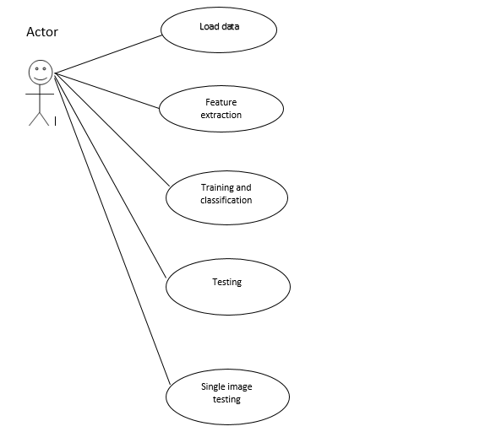

1.6.2 Usage Scenarios
Data Load

Use case | Data load
Use case id | 1
Actor | Admin
Description | Admin upload the training dataset

Feature Extraction

Use case | Feature extraction
Use case id | 2
Actor | Admin
Description | Admin extract the features of given dataset

Training and Classification

Use case | Training and classification
Use case id | 3
Actor | Admin
Description | Train and Classify the model using extracted features

Testing

Use case | Testing
Use case id | 4
Actor | Admin
Description | In this step test the model using test dataset

Testing Single Image

Use case | Testing single image
Use case id | 5
Actor | Admin and user
Description | Admin and user can use the application using single image

  - Development Methodology
Spiral Methodology, Prototyping Methodology, Waterfall Methodology
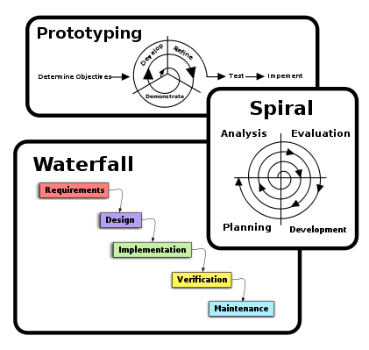
Spiral Model

The spiral model is a risk-driven process model generator for software projects. Based on the unique risk patterns of a given project, the spiral model guides a team to adopt elements of one or more process models, such as incremental, waterfall, or evolutionary prototyping.
Prototyping Model

The Prototyping Model is a systems development method (SDM) in which a prototype(an early approximation of a final system or product) is built, tested, and then reworked as necessary until an acceptable prototype is finally achieved from which the complete system or product can now be developed. This model works best in scenarios where not all of the project requirements are known in detail ahead of time. It is an iterative, trial-and-error process that takes place between the developers and the users.
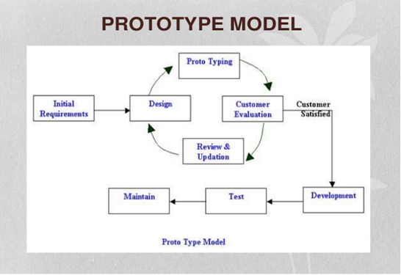

Waterfall Model

The waterfall model is a sequential (non-iterative) design process, used in software development processes, in which progress is seen as flowing steadily downwards (like a waterfall) through the phases of conception, initiation, analysis, design, construction, testing, production/implementation and maintenance. Despite the development of new software development process models, the Waterfall method is still the dominant process model with over a third of software developers still using it.
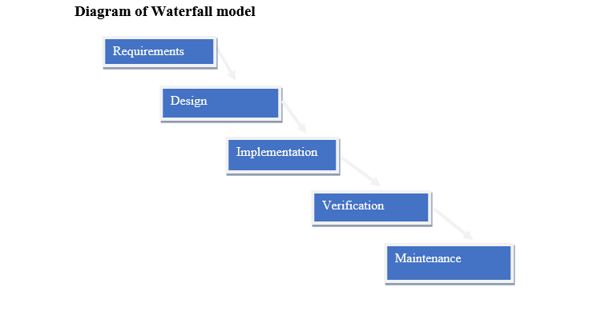

1.7.1 Chosen Methodology

I have been studied all the methodologies and then I choose the Virtual University Model for my project. University also guides us that you must use Virtual University Model for project and this model full fills all the project requirements. So I chose VU Model. The detail of VU Model is as under.
- System Requirement Specification (SRS)
- Design phase.
- Test phase 1
- Test phase 2
- Development
- Final Report
- Presentation and viva
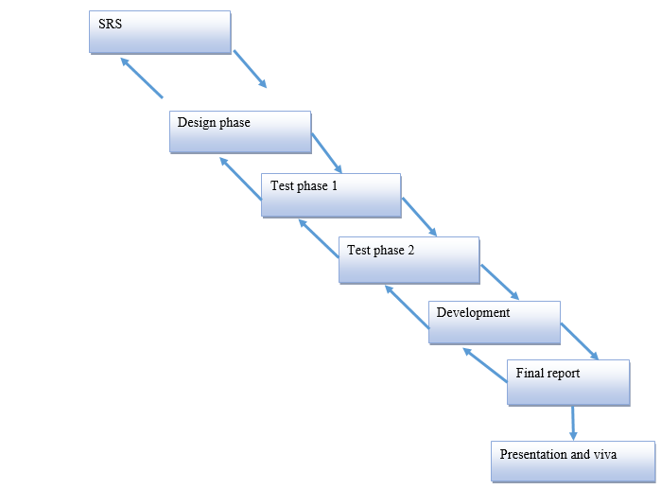

1.7.2 Reasons for Chosen Methodology
I choose VU model for my project. Reasons for adopting this methodology is as under.
- Virtual University of Pakistan guides us that you must select VU Model for project.
- Only VU Model full fills all the requirements of my project.
- VU Model is the combination of Waterfall and Spiral methodologies. One feature of waterfall methodology is the sequence of steps that we take in our methodology and one feature of spiral methodology is to go previous steps. This feature also we include in our methodology.

1.7.2 Work Plan (Gantt chart)
Arranging is imperative piece of begin of any project on the grounds that on the off chance that it is arranged in a decent way then it will make an effective and important project. Graphical representation of time taken to finish the project will likewise be appeared.

1.7.2 Project Schedule (Submission Calendar)
Plan consists of following stages.
- Team structure
- Detailed project schedule

Team Structure

The project Shape classification using SVM consists of two members one Supervisor and one Developer.

Supervisor

Developer

Gantt chart
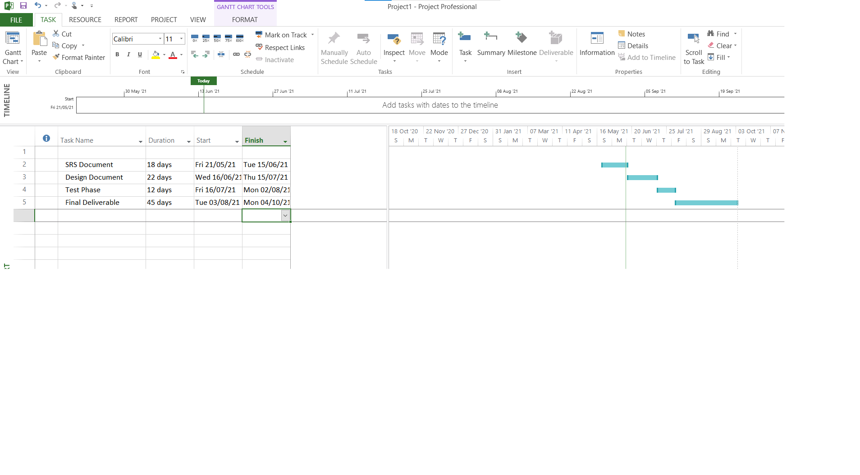

CHAPTER 2
Designing the Project

  - Introduction

In the design phase document our focus is what to do and how to do. It means how the problem will be solved and which tools and techniques will be used. Much care is taken during the design phase because any mistake in this phase could be very expensive to solve in he later stage of the software development. The purpose of design phase is to plan out a system that meets the requirement defined in the analysis phase.
Design document includes Sequence Diagram, Architecture Diagram, Class diagram and Interface Diagram.
- Sequence Diagrams: It shows the messages exchanges between entities. How and when one entity sends message to other and get response.
- Architecture Diagram: It shows different module called layers. User requests flow to the destination by passing different isolated layers.
- Class diagram: It defines the properties and behavior of different classes and their relation is also mentioned in these diagrams.
- Interface Diagram: The interface diagram show that how does a system looks like and how is its front end. This diagram provides the interface of the system.
- Test Cases: Finally On the basis of different use cases the test cases are created.

2.2 Architectural Representation (Architecture Diagram)
Architecture Diagram shows different layers, their relation and separation and how and what sequence request from user is conveyed. The architectural design is the design of the entire software system; it gives a high-level overview of the software system, such that the reader can more easily follow the more detailed descriptions in the later sections.
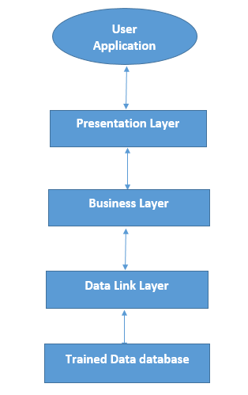

2.3 Dynamic Model: Sequence Diagrams

The sequence diagram show the interactions between objects in the sequential order that those interactions occur. It is an interaction diagram that shows how processes operate with one another and in what order. It show the task sequence of the system shows how entities exchanges messages among one another. It also shows the time of each message.
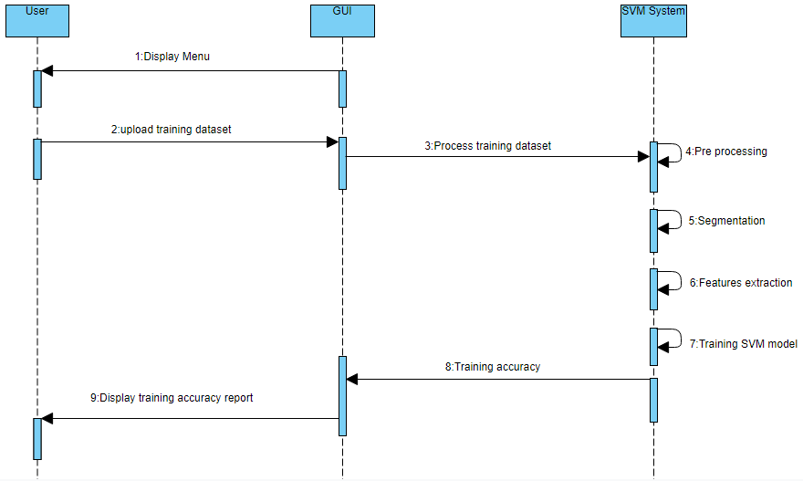
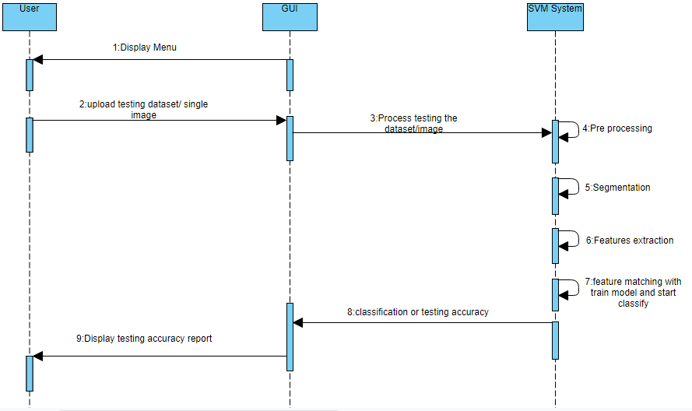

2.4 Object Model/Logical Model: Class Diagram

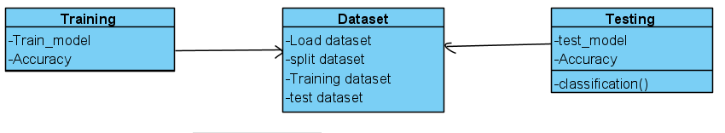
2.5 Graphical User Interfaces

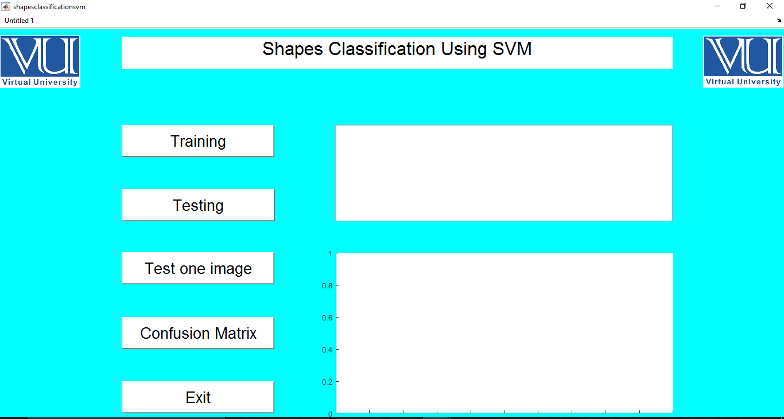

CHAPTER 3
Development

Introduction
In this chapter we describe the methodology and development of the project. We discuss in this project about dataset also. Architecture diagram for this process is given below.
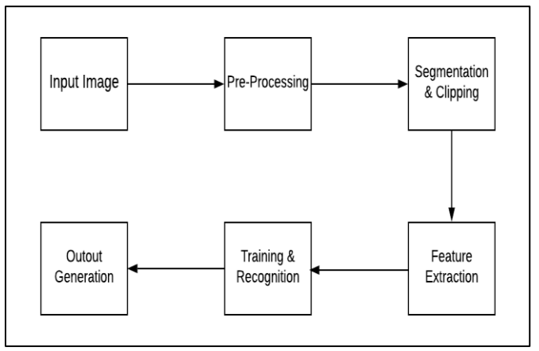

Dataset
We create dataset using paint. We create 40 images of different sizes 10 of each shape. Then after creating 40 images we apply augmentation technique to increase dataset from 40 to 400 images 100 of each shape. After this we spilt the dataset in two parts 70 percent for training the model and 30 percent for testing the model.


Fig: Circle Fig: Rectangle


Fig: Square Fig: Star

3.3 Features Extraction
This is the very most important part image classification. Before training the model our main task is to extract features of the dataset. Then we use these features to train the model for classification. Following are techniques to extract features from dataset.
- Local binary pattern
- Histogram Oriented Gradient
And many more techniques are used for Features extraction.

Local Binary Pattern Technique

Local Binary Pattern (LBP) is a simple yet very efficient texture operator which labels the pixels of an image by thresholding the neighborhood of each pixel and considers the result as a binary number. It was first described in 1994 (LBP) and has since been found to be a powerful feature for texture classification. It has further been determined that when LBP is combined with histograms of oriented gradients (HOG) descriptor, it improves the detection performance considerably on some datasets. Using the LBP combined with histograms we can represent the face images with a simple data vector.

3.3.2 Histogram Oriented Gradient
Histogram of Oriented Gradients, also known as HOG, is a feature descriptor like the Canny Edge Detector, SIFT (Scale Invariant and Feature Transform). It is used in computer vision and image processing for the purpose of object detection. The technique counts occurrences of gradient orientation in the localized portion of an image. This method is quite similar to Edge Orientation Histograms and Scale Invariant a Feature Transformation (SIFT). The HOG descriptor focuses on the structure or the shape of an object. It is better than any edge descriptor as it uses magnitude as well as angle of the gradient to compute the features. For the regions of the image it generates histograms using the magnitude and orientations of the gradient.

3.3.3 Gray level co-occurrence matrix(GLcM)
A statistical method of examining texture that considers the spatial relationship of pixels is the gray-level co-occurrence matrix (GLCM), also known as the gray-level spatial dependence matrix. The GLCM functions characterize the texture of an image by calculating how often pairs of pixel with specific values and in a specified spatial relationship occur in an image, creating a GLCM, and then extracting statistical measures from this matrix. (The texture filter functions, described in Calculate Statistical Measures of Texture cannot provide information about shape, that is, the spatial relationships of pixels in an image.) . By using this technique we find contrast, correlation, energy and homogeneity features of dataset images.For this project we are using HOG features extraction technique. We apply this technique on dataset and get the features vector.

Classification Algorithm
After the process feature extraction we pass the features in training process using Support vector machine (SVM).

Support vector machine (SVM)
A support vector machine (SVM) is a supervised machine learning model that uses classification algorithms for two-group classification problems. After giving an SVM model sets of labeled training data for each category, they’re able to categorize new text. Compared to newer algorithms like neural networks, they have two main advantages: higher speed and better performance with a limited number of samples (in the thousands). This makes the algorithm very suitable for text classification problems, where it’s common to have access to a dataset of at most a couple of thousands of tagged samples.
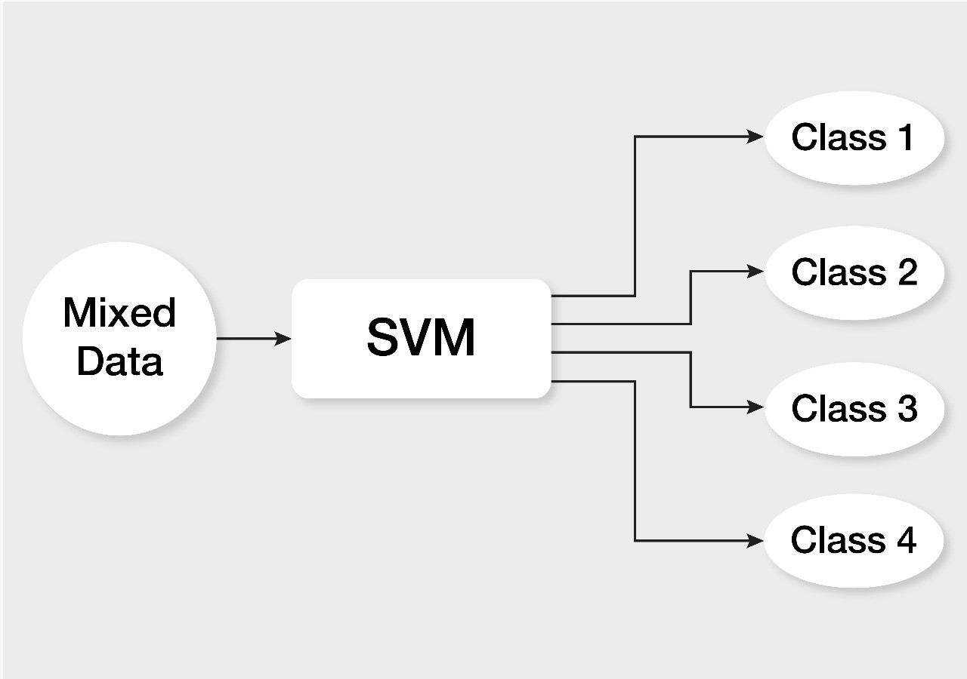

Fig: Support vector Machine Algorithm

Training
After features extraction we train the model using SVM algorithm. After training the model and classify the dataset successfully.

Testing
After training the model we test the model on test dataset and get accuracy of almost 93%. We also test the model using single image and get the accurate result. Confusion matrix of model on test data is.

Confusion matrix
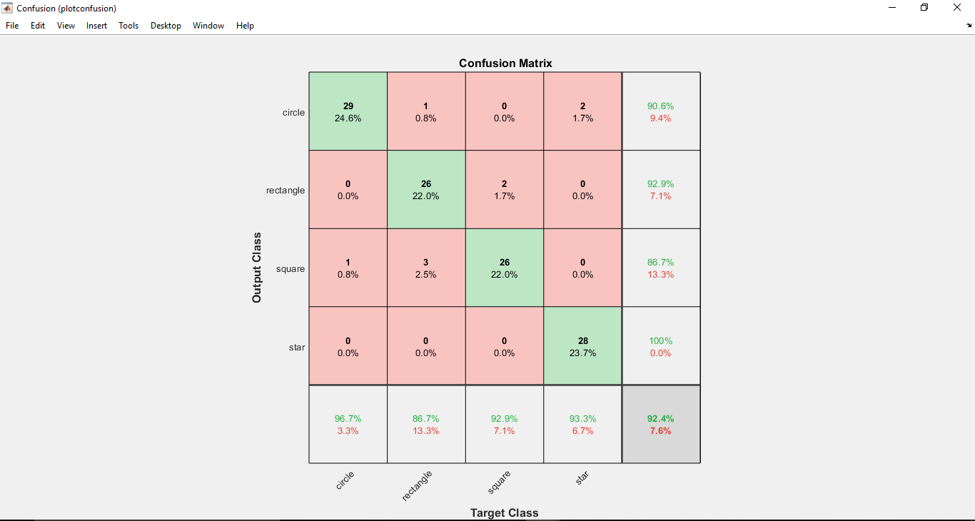

Graphical User Interface

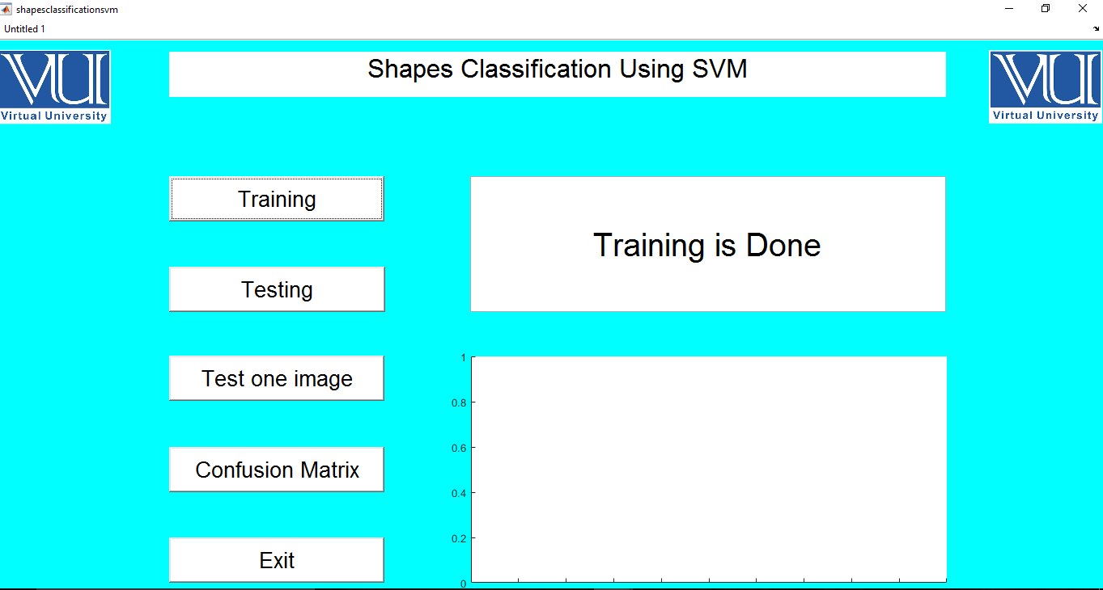

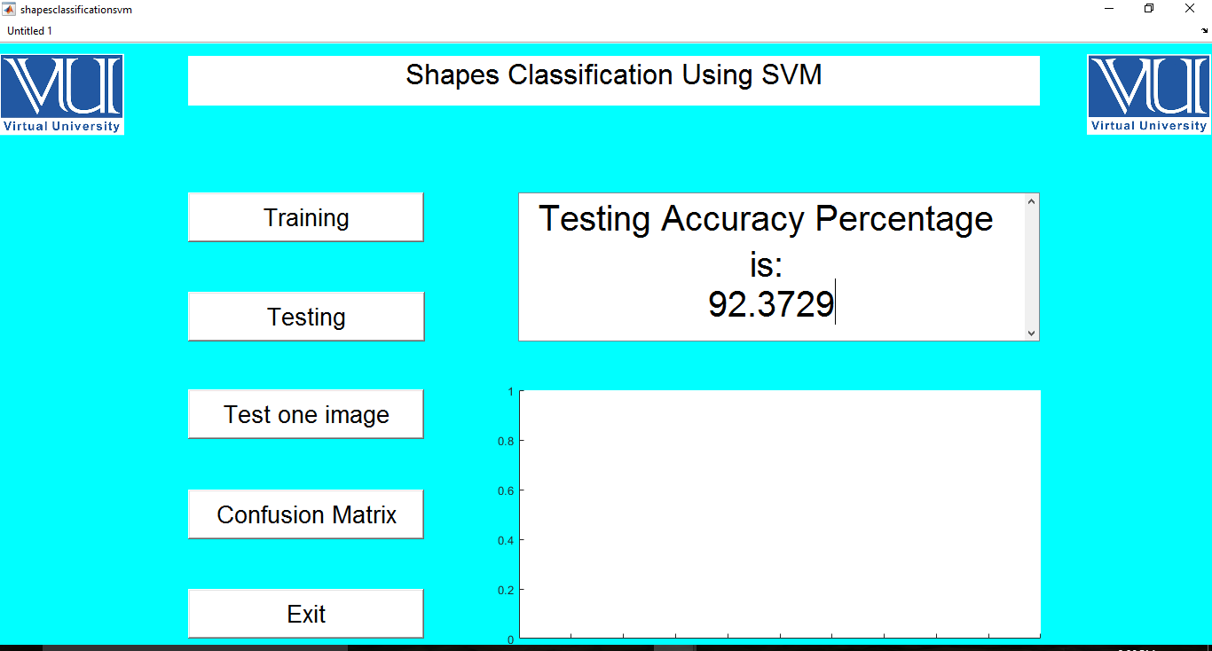

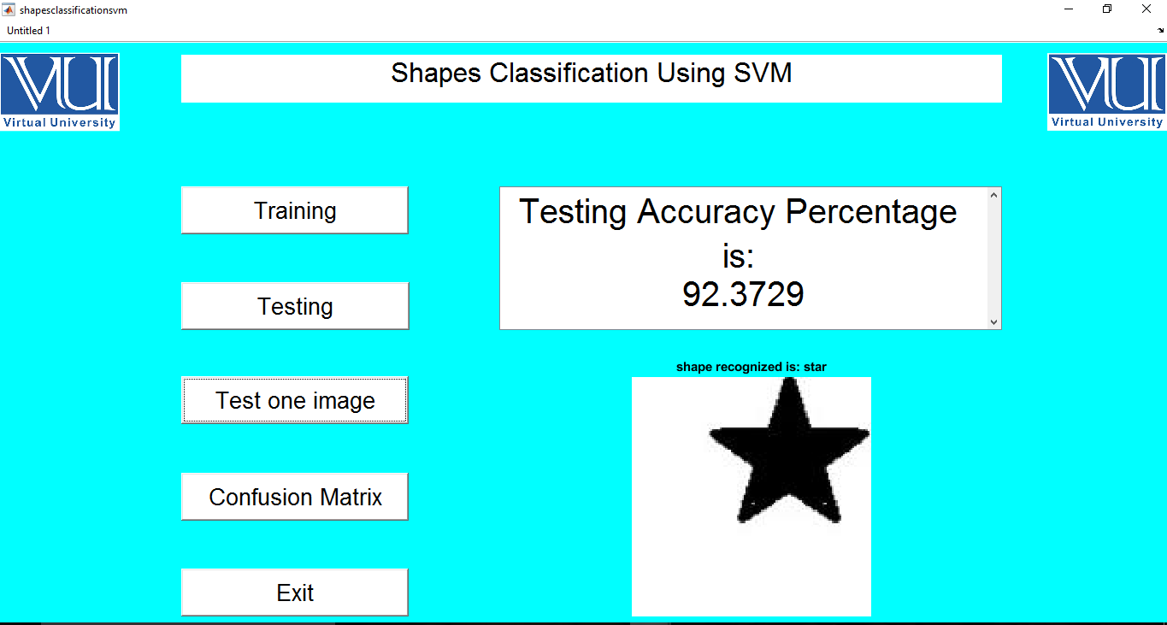

REFERENCES

[1] | R. Dwivedi, "How Does Support Vector Machine (SVM) Algorithm Works In Machine Learning?," 2020.
[2] | R. Pupale, "Support Vector Machines(SVM) — An Overview," in https://towardsdatascience.com/https-medium-com-pupalerushikesh-svm-f4b42800e989, 2018.
[3] | M. Tyagi, "HOG (Histogram of Oriented Gradients): An Overview," https://towardsdatascience.com/hog-histogram-of-oriented-gradients-67ecd887675f.

[4] https://www.mathworks.com/help/images/texture-analysis-using-the-gray-level-co-occurrence-matrix-glcm.html

